**CSS Module Project**

**1) Index.html: -**

Index module are containing the main part of project.

In the index module we link the style of the module from style.css and we also take font family form google font.

In the body section we take a div for button and an image and declare a class of name rest.

**2) style.css: -**

Style.css file is CSS file which is use to design the index.html file context.

In the file we firstly take background image and design by CSS. After that div that class name rest design. And button, button-hover and anchor tag design.

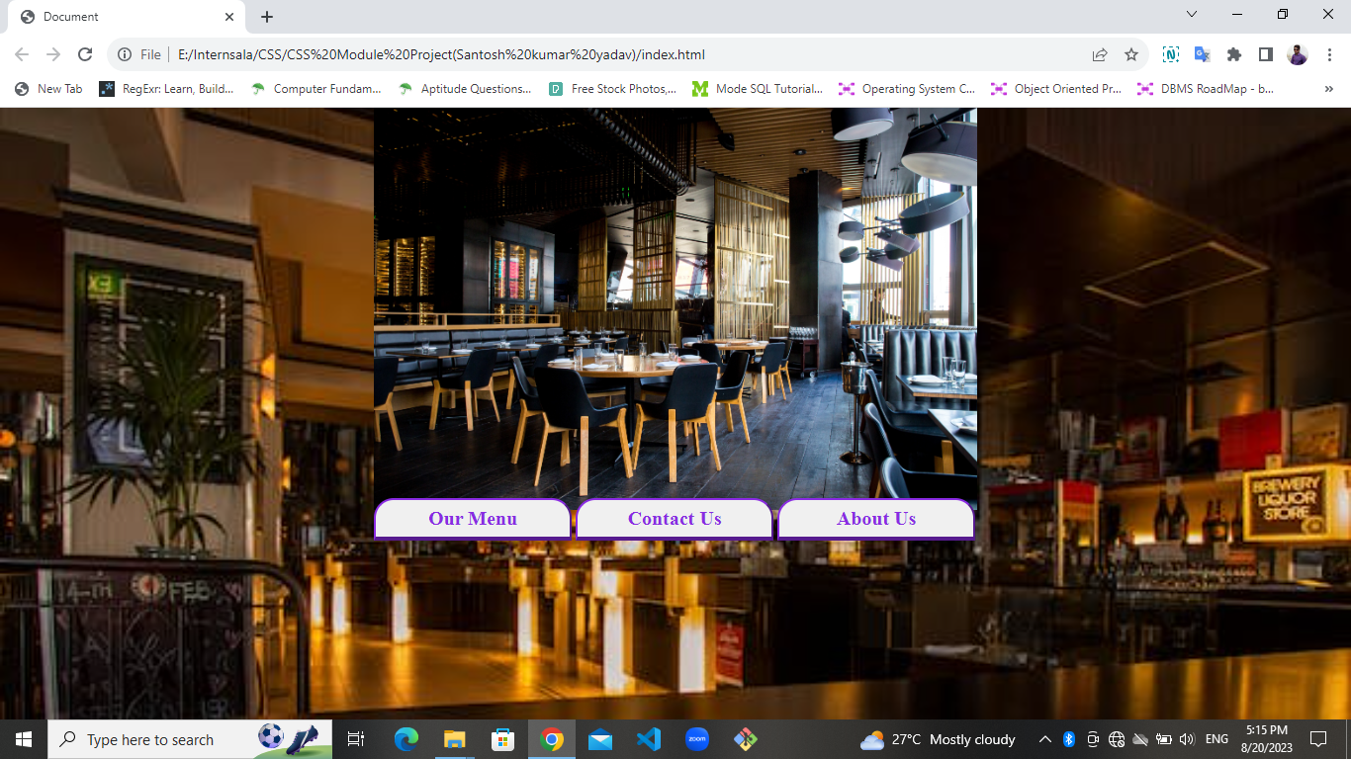

**3) Menu.html: -**

Menu page show the items which we have for Breakfast and lunch. For design this page we take font-family form google font and. We take a large button and some small button and as well as some image of items which we have.

**4) stylemenu.css: -**

This is a CSS file which is use to design the menu.html file by using some class largebutton smallbutton imgdiv and img for image tag design them according to their requirement.

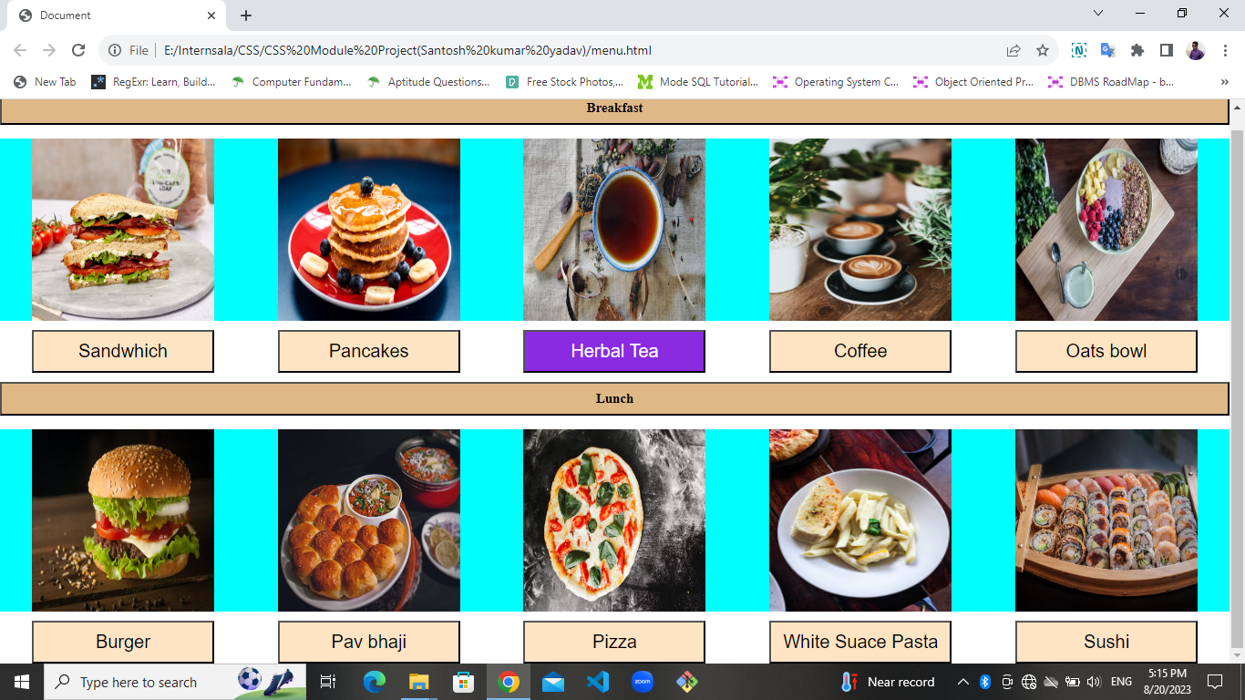

**5) contact.html: -**

This page is use for connect the people. And make connection between the web server and this is use in future. We use internal CSS to design the page and make contact page. We use simple form tags and button tag to make the page.

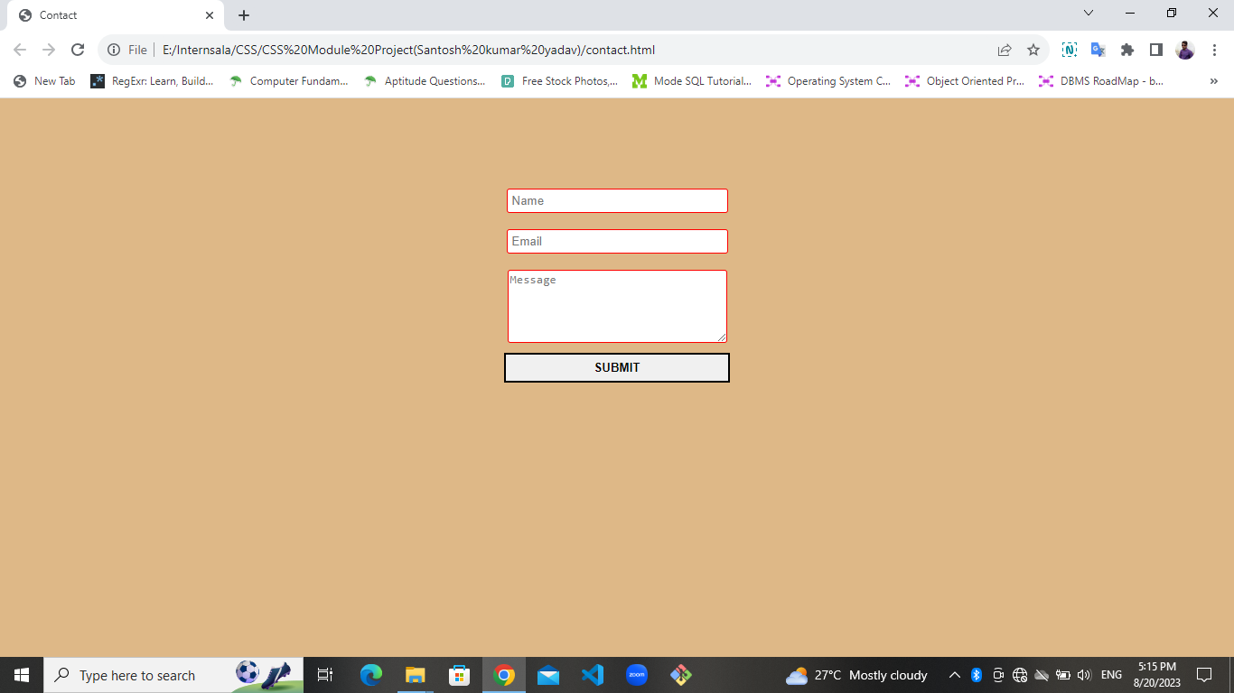

**6) about.css: -**

About us page is show the which services provide by the website. We are using the internal CSS to design the page. We design the button and body. body design by using liner-gradient.

